Ruprecht-Karls Universität Heidelberg

Geographisches Institut

Berliner Straße 48

69120 Heidelberg

**Impact of a new minimum distance between wind turbines and settlements –**

GIS Analysis with free geodata

Course: **GIS Analyses with Free and Open-Source Software**  
Winterterm 2019/20

|  |  |
| --- | --- |
| Lecturer: | Christina Ludwig, M.Sc |
| Handed in by: | Group 5:   |  |  | | --- | --- | | Carsten Gawlas  Student number: 3604077  bs251@stud.uni-heidelberg.de | Ulrike Lorenz  Student number: 3600484  Ulrike.Lorenz@stud.uni-heidelberg.de | |
|  |  |
| Heidelberg, the | 30.03.2020 |

**TABLE OF CONTENTS**

TABLE OF FIGURES 3

TABLE OF CHARTS 3

ABSTRACT 4

Offene Fragen 5

Grading criteria 5

1 Introduction 5

1.1 Target/Hypothesis: 5

1.2 Location 6

2 Background 8

3 Data/Methods 10

3.1 Data 11

3.2 Methods 12

4 Results 15

5 Discussion (Mache ich !!!!) 18

6 Outlook 19

7 Sources: 20

8 Declaration of Authorship 22

# TABLE OF FIGURES

Figure 1: Map of the research area 7

Figure 2: Elevation of the Research Area 8

Figure 3: Nameplate capacity of wind energy per year 9

Figure 4: Net electricity production in Germany (2019) 10

Figure 5: Workflow 14

Figure 6: Result of the two distances 15

Figure 7: Centroids of the most suitable areas with the old and new buffer distance to settlements 17

# TABLE OF CHARTS

Table 1: Data Sources 11

Table 2: Comparison of the not available area regulated by minimum distances to infrastructure and settlements 15

Table 3: Classification of land uses for a wind turbine park 16

# ABSTRACT

Germany wants to shift his energy source from fossil to renewable sources. The biggest share from renewable source will oblige to wind energy. The German government built up the capacitate of Wind turbines. In 2019 nearly 25% of the electricity in Germany was produced from wind energy. Because the expansion of wind turbines slowed down rapidly, there were different proposals to increase the build-up of wind turbines again. This paper examined the idea of increasing the minimum distance between Wind turbines and human settlements. For this the areas, in which potential wind turbines could be build, was calculated. First the area with the old requirements and with the new proposal were calculated and then compered. The calculation was done with a batch process written in QGIS. The data used in this paper, were open source, as the used tools were. This was done for the purpose of making the calculation repeatable for everyone. Because of that the documentation is published on GitHub (https://github.com/UlrikeLorenz/Final_Project_Group5) for repeating the calculation or for applying this method on other areas. In this paper the API overpass turbo was used to download the Data from OSM. The code can easily be modified to any other region in BW (Germany).

This paper shows that for the region of Rhein-Neckar-Kreis and Neckar-Odenwald-Kreis the change of the minimum distance makes a significant difference. Some areas that were appropriate were no longer available according to the new minimum distance to settlements. Espacially for Rhein-Neckar-Kreis the impacts were strinking: Only few areas were available by the old minimum distance to settlments and with the new regulations it would be even less and makes the implementation of the goals impossible within the area itself. This seems to be less problematic in Neckar-Odenwald-Kreis, but will probably be a problem in other regions in Germany too.

# 

# Offene Fragen

|  |
| --- |
| -Mindestfläche WEA? |
|  |

|  |
| --- |
| -Landuselayer? (Bisheriger Lückenhaft) |
|  |

|  |
| --- |
| -Höhe WEA? |
|  |

|  |
| --- |
| -Quelle Eingabewerte oder eigene Festlegung? |
|  |

-Literaturteil für Report?

# Grading criteria

* Originality of your project idea
* Literature and data research
* Conceptualisation and automated implementation of your analysis
* Documentation, readability and executability of your model scripts
* Critical evaluation of your results

# Introduction

Germany works on the shift from fossil energies to renewable energies. This is even enshrined in German laws. The main part of the energy from renewable energies is wind energy. The state of Baden-Württemberg in southern Germany aims to get 10% of the needed energy out of wind energies produced within the state until 2020 (Windenergieerlass Baden-Württemberg 2012). Because of a raising resistance of local resident against wind turbines, the where different approaches in getting a higher acceptance in the population. In 2019 the German Government suggested a new law for Wind turbines. The proposal commands a new minimum distance of wind turbines from settlements. Even though the proposal is not yet implemented, it raised many questions on the impact of this law. The idea is caused strong sceptics, if the actions fulfil the task. The board member and responsible for the energy policy of the union Verdi, Wolfgang Lemb disagreed with this idea. He said that the new minimum distance of 1000m will not increase the acceptance, it will only decrease the potential area for wind turbines (Der Spiegel 2020). The questions are, how much area will be affected by these new requirements? Will the new minimum distance have an impact in impeding the goals for expanding wind turbines?

## Target/Hypothesis:

To achieve the goal of more renewable energies it is necessary to find suitable places for new wind turbine parks. The target of this project is to calculate the total area, which is lost as potential locations for wind turbine parks by the new required distance to settlements. Is the new distance creating a big (significant) impact?

Furthermore, the available areas will be evaluated and clipped by further relevant data like maximum slope, wind data and landuse. This will answer the Question: Which area/s is/are most suitable for a wind turbine park in the study area? This will also show if the new distance has a significant impact on the seize and geographical position of the most suitable area(s).

## Location

The research area consists of the Rhein-Neckar-Kreis and the Neckar-Odenwald-Kreis. The research area should be near the City of Heidelberg (see Figure 2: Map of the research area), which is located in the south-west of Germany, in the north of Baden-Württemberg. It is assumed that both the region of Mannheim and the region of Heidelberg are not suitable for a wind turbine park. Because the regions are to small and the population density is too high. Because of that, the analysis for possible locations for wind turbines is performed within the regions of Rhein-Neckar-Kreis and Neckar-Odenwald-Kreis (see research area in Figure 2). The research expands over two main districts, this is the Oberrheingraben in the west, which has a really low Elevation (see Figure 3) and nearly no slope. In contrast to the other region (anderes Wort!), the Odenwald. The Odenwald is in the north and north-west of the Region. This mountain region has a higher elevation and has a heterogenic surface, with peaks and valleys, so the slope is much higher. That means the research area consist of two different regions, one really flat and dominated by agriculture and the other one really hilly (Figure 2: Elevation of the Research Area).

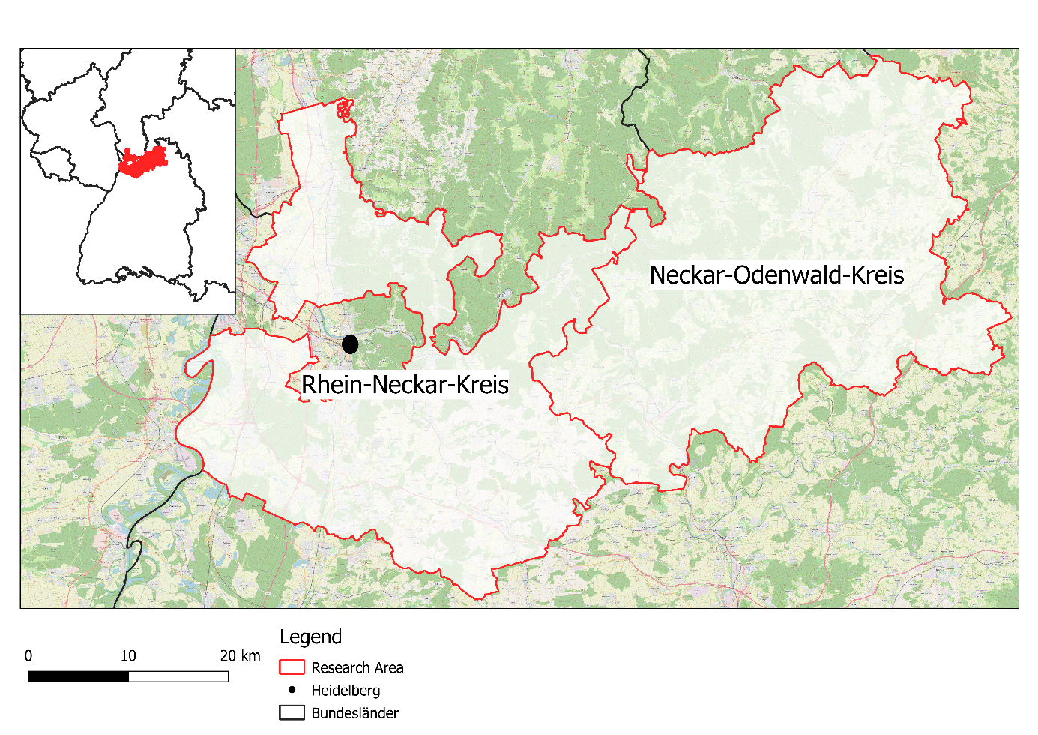

Figure 1: Map of the research area

Source: own map with data from OpenStreetMap contributors (2019)

Ein Bild, das Text, Karte enthält.

Figure 2: Elevation of the Research Area

Source: own map

# Background

In 2019 127,22 TWh of electricity was produced by wind turbines in Germany. This is 24,6% of the total generated electricity in Germany in 2019. This means that wind energy is the biggest energy source in Germany (Figure 3). The production growth from 2018 to 2019 was nearly 16%. The total wind energy production is divided in offshore and onshore wind energy. The onshore wind turbines produced in 2019 102,6 TWh, so they are much more important at the moment than the offshore turbines, which produced 24,62TWh (Burger 2020: 5).

A big Problem is the fluctuation in the amount of energy gained from wind. In Germany the gained energy from wind, changes on a daily to monthly basis. For example, in 2019 the amount of energy change from 18 TW/h in March to 6 TW/h in August (Burger 2020: 28). The main problem is that the build-up of wind energy is decreasing (see Figure 3). Specially the expansion of onshore wind turbines is slowing down since 2017 (Figure 3). This is a problem when the capacity for Wind energy is not increased, because then the goal to shift completely from fossil energy to renewable will not be possible. The new law for stopping the use of coal till 2038, the Kohleausstiegsgesetz (Bundesregierung 2020: 17) will also, increase the pressure on the expansion of wind energy capacity.

Figure 3: Nameplate capacity of wind energy per year

Source: own Figure with data from Burger 2020: 58

Figure 4: Net electricity production in Germany (2019)

Source: Own Figure with data from Burger 2020: 13

For finding suitable areas the must be considered many different Criteria, the most important criteria to find a suitable location for a wind turbine park are the wind speed and the profitability considering the energy the park can produce and the coast of building and operation services. Criteria are divided in two groups: knock-out criteria and trade-off criteria. Knock-out criteria consider any form of settlement, traffic areas, energy pipelines/cables, radio stations, military stations, airports (no matter which size), nature and landscape aspects, waterbodies, some sorts of forest (protected, to use for relaxation or soil protection) and areas where natural resources are exploited. Trade-off criteria consider also nature and landscape aspects, regional important relaxation areas and cultural and soil landmarks (Gesellschaft für Landmanagement und Umwelt mbh 2013). For many of these criteria a certain distance to wind turbine parks is necessary as proposed in Bergmann and Höfle (2013).

# Data/Methods

The potential of free geodata in comparison with official geodata was investigated by Bergmann & Höfle (2013). They conclude that the free geodata are not as exact as official data, but the spatial location is nearly identical. In their conclusion free geodata can be used, to detect areas with potential locations for wind turbines.

To determine potential location, different parameters must be considered. This is the optical impact of wind turbines, which was analysed in a GIS-based approach by Taeger & Ulferts (2017). A different parameter is noise, but with a distance of 1000m noise surveys are no longer necessary (Lechleitner & Bohm 2016).

## Data

In this project free geodata, like OpenStreetMap will be used. The reasons for using free Geodata is, that it is free, easier to access and has already been used in analysis of potential wind turbines location (Bergmann & Höfle 2013). Within that study several tags are used to get the useful data, which will be adapted to our study and used in this analysis too. The following tags should be used for the analysis: landuse=residential/ farmyards/ industrial/ commercial, railway, aeroway=runway/ taxiway/ terminal, power=line/ minor_line, boundary=protected_area, leisure=nature_reserve, highway=motorway/ motorway_link/ trunk/ trunk_link/ primary/ primary_link/ secondary/ tertiary (Bergmann & Höfle 2013, adapted).

For the regions either OSM data (boundary=administrative (admin_level=8)) or other data sources (e.g. https://gadm.org/download_country_v3.html) can be used.

To get the best results both data should be downloaded and compared to find which one suits best for the analysis and to get an impression of the OSM data.

For the analysis is an elevation model necessary, free data is provided by several sources. The main difference is the spatial resolution. Because of the pretty small regions that are considered in this project, a high spatial resolution is necessary. This can be found at <https://www.opendem.info/download_srtm.html>.

Winddata can be found from several sources too. The most reliable sources for this project are the “Windatlas Baden-Württemberg” (<https://www.energieatlas-bw.de/wind/windatlas>) and the german weather service (which gives even more data by predictions for the future)( <https://www.dwd.de/DE/leistungen/quwind100/qu-wind_100.html>).

Table 1: Data Sources

|  |  |  |  |  |
| --- | --- | --- | --- | --- |
| Name | Content | Spatial resolution | Year from | Source |
| Windatlas Baden-Württemberg | Winddata in an elevation of 100-200 m above the ground (used here: mean wind speed in 200 m) | 30 x 30 m | 2019 | https://www.energieatlas-bw.de/wind/windatlas |
| DEM | Elevation | 0.0008333333333333301342 x 0.0008333333333333301342 ° | ??? | https://www.opendem .info/download_srtm.html |
| CORINE Landcover von Copernicus | Landusedata | 100 x 100 m | 2017-2018 | https://land.copernicus.eu/pan-european/corine-land-cover/clc2018 |
| OSM | Aeroways, farmyards, industrial/commercial areas, streets, regions, powerlines, wind turbines | - | 2019-2020 | https://www.openstreetmap.de/karte.html |
|  |  |  |  |  |

## Methods

The analysis will mostly be done within QGIS. Depending on the datasets a preprocessing can be done with help of GDAL. The data can either be downloaded by hand or can be downloaded by an automated script containing the OSM tags.

Every dataset must be buffered with the distance that is required according to German law. To see the difference that results from the new proposed distance to settlements, that layer must be buffered twice: With a buffer distance of 1000 m and a buffer distance of 700 m. All buffer layers must be merged and clipped with the administrative areas of the two regions to see possible areas for wind turbine parks and if the areas change depending on the new distance to settlements. For the possible areas an elevation analysis is needed to see if the areas are flat enough to build a wind turbine park on them.

Dolinski et al. (2012 Seitenzahl ) propose an analysis with commercial programmes, but most of the analysis can also be done with QGIS. But also a script for GRASS GIS can be used to analyse the parameters for the potential wind turbine location (Bergmann & Höfle 2013 Seitenzahl). Using free software and data allows the repetition of this analysis in different areas.

The input data must be weighted according to their importance. The most important data to find the most suitable area for a wind turbine park is of course the wind itself. If there is no wind or too little in the height of the wind turbine (about 150-200 m above the ground) no wind turbine park would make sense. But even if there is wind it should not be too windy too because otherwise the wind turbine park has to be shut down when wind speed is too high so the gained energy would be less. On top of that the elevation and slope should be considered. Both are important factors because if an available area is in a valley it does not make sense to built a wind turbine park there. The slope can be a knock-out-criteria too, because only small slope values are allowed. High slope values would mean that the area contains a hillside which means that the wind park would contain wind turbines on lower sites which would produce less energy. That’s why the elevation should preferably be more or less evenly distributed, but should at least not have big differences. The last dataset that is really important is land use data. This dataset contains some knock-out criteria too. The land use is partly already included in the analysis (like settlements are already considered), but for example a big lake or river within a possible available area would make that area less attractive.

To work together on the project a GitHub repository is used (<https://github.com/UlrikeLorenz/Final_Project_Group5>).

This analysis has as usual some limitations. First of all is the fact that the analysis gives a hint which areas are suitable, but the results are not compulsory. The communities decide where a wind turbine park should be built or not. For many communities in Germany possible areas for wind turbine parks are already marked in the obligatory plans (like for example Flächennutzungsplan).

Another problem is the fact that some data could not be included in the analysis because it is simply not available. This includes data about vegetation and animals in the possibly available areas. That data is actually an important knock-out criteria for some areas, but often not analyzed before concrete plans for a specific area are made. Some habitats are even protected by German or European law, but now all protected areas are available as dataset, especially in more rural regions, so this could not be considered too.

Figure 5: Workflow

Source: own figure

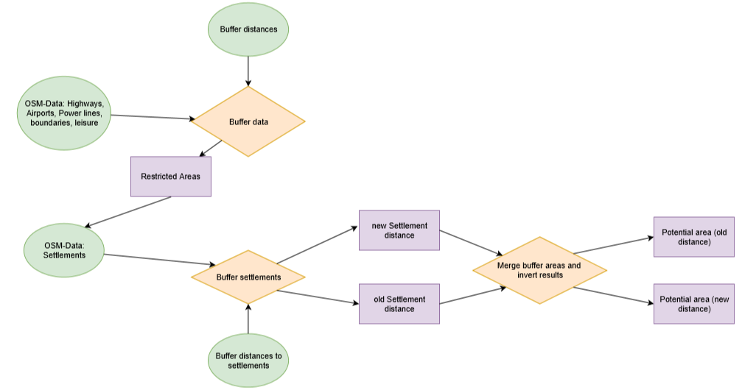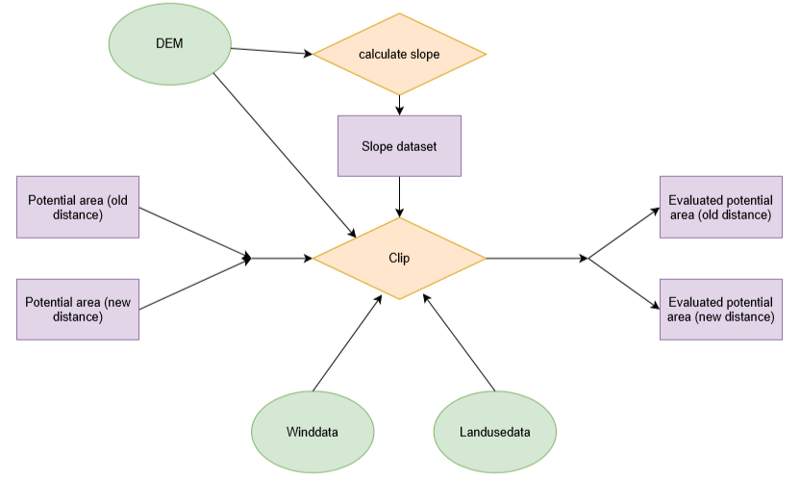

# Results

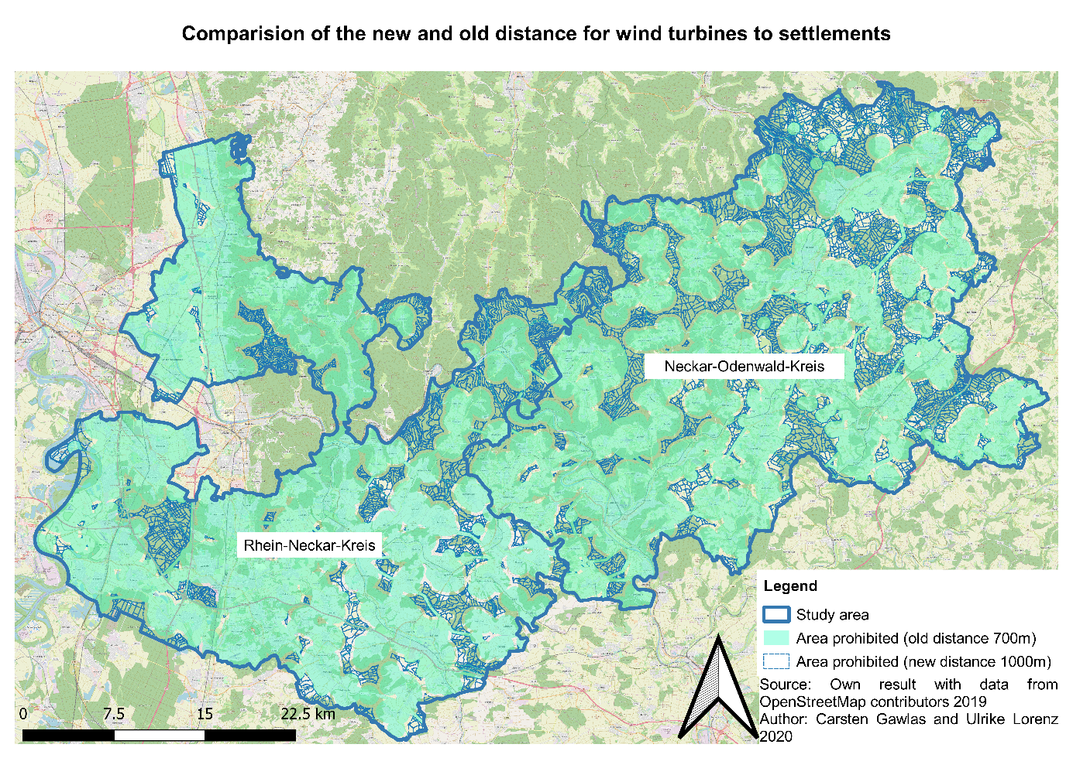

Figure 6: Result of the two distances

Source: own figure with data from OpenSteetMap contributors (2019)

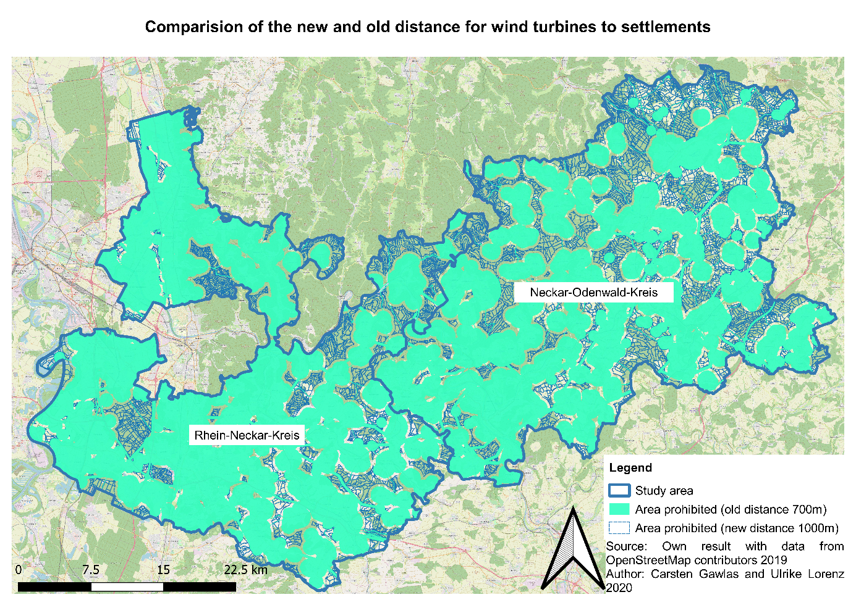

First of all, the area of both layers that is not available is counted to calculate the difference. This is done with the statistics tool. To do so the results are first warped to UTM, to get reliable results. This gives the Table 2.

Table 2: Comparison of the not available area regulated by minimum distances to infrastructure and settlements

Source: own figure

|  |  |  |  |
| --- | --- | --- | --- |
|  | Old Distance | New Distance | Difference |
| Overall Area [m²] | 2186176586,145 | 2186176586,145 | - |
| Unavailable Area [m²] | 1460894414,7458239 | 1710253943,806782 | 249359529,0609581  (249,36 km2) |
| Unavailable Area [%] | 66,82% | 78,23% | 11,4% |

This shows that the overall impact is significant. More than 10% of the overall area are no longer available for a wind turbine park when using the new distance to settlements.

With a second model the most suitable places within the remaining area are found. This means that first the area of each polygon (divided by streets) is calculated because a minimum area of 300 m² is needed to build a wind turbine park with three wind turbines. Then the slope is calculated. Slope should have a maximum value of 30 degrees. Later on, the windspeed in a height of 200 meters is considered too. A minimum mean wind speed of 6 meters per second is needed to have a productive wind turbine park. Furthermore, the land use is considered. The land use layer is reclassified by Table 3.

Table 3: Classification of land uses for a wind turbine park

Source: own figure

|  |  |
| --- | --- |
| Land use | Available for a wind turbine park |
| Airports | No |
| Broad-leaved forest | Yes |
| Complex cultivation patterns | Yes |
| Coniferous forest | Yes |
| Continuous urban fabric | No |
| Discontinuous urban fabric | No |
| Dump sites | No |
| Fruit trees and berry plantations | Yes |
| Green urban areas | No |
| Industrial or commercial units | No |
| Inland marshes | No |
| Land principally occupied by agriculture with significant areas of natural vegetation | Yes |
| Mineral extraction sites | No |
| Mixed forest | Yes |
| Natural grasslands | Yes |
| Non-irrigated arable land | Yes |
| Pastures | Yes |
| Road and rail networks and associated land | No |
| Sport and leisure facilities | No |
| Transitional woodland-shrub | Yes |
| Vineyards | Yes |
| Water bodies | No |
| Water courses | No |

After looking up all those criteria for each remaining polygon the remaining areas are marked by a centroid to make is possible to show all areas within the study area. This analysis is made for the areas remaining after buffering with both the old and the new distance. To see the differences a layout with both results is chosen.

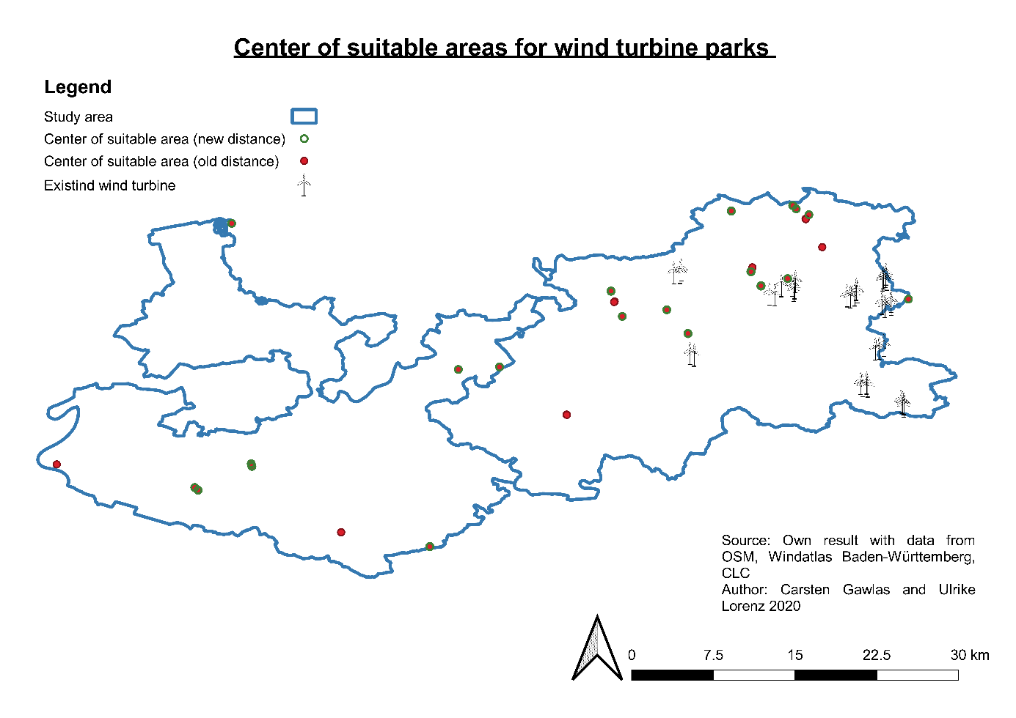

Figure 7: Centroids of the most suitable areas with the old and new buffer distance to settlements

Source: Own figure with data from OpenSteetMap contributors (2019), Albrecht et al. (2019) and Copernicus Land Service (2018)

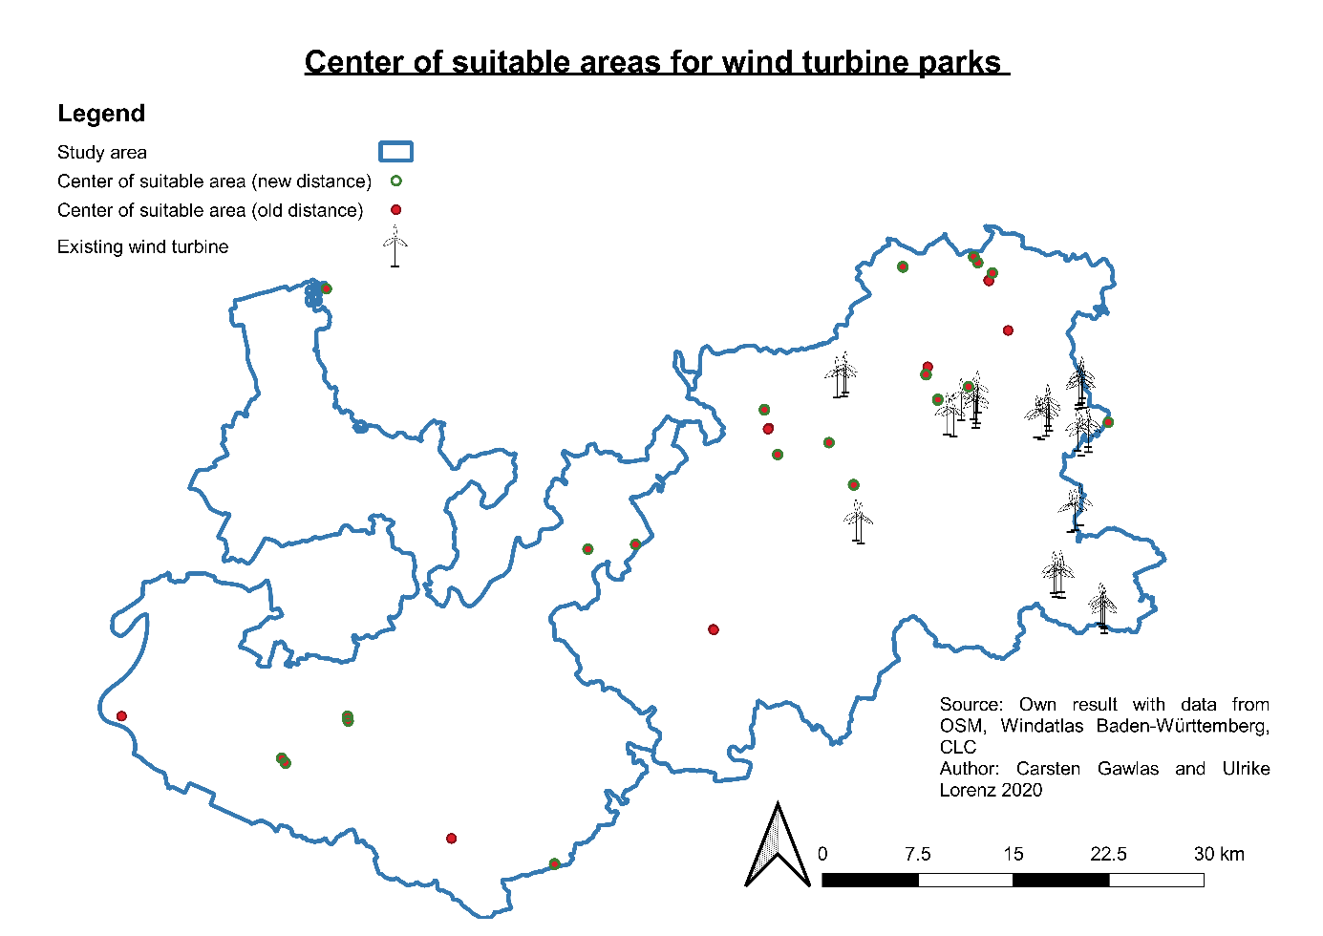

According to the results shown in figure 7 we can see that the new minimum distance has an impact. We can see that in some areas the results are the same, but obviously there are more red dots than green ones. This means that we get more areas that fulfil all criteria with the bigger areas of the old buffer distance to settlements. Some of these results are close to other areas, so their weight is pretty small. But we can see four red dots that are far from other dots, two in Rhein-Neckar-Kreis and two in Neckar-Odenwald-Kreis. These results are really important because those areas can´t be considered any longer. Four really good locations get lost by the new minimum distance to settlements.

To see if the results are meaningful, already existing wind turbines are added to the results. We can fist see that there are only wind turbines in Neckar-Odenwald-Kreis, but none in Rhein-Neckar-Kreis. This shows again that the expansion of wind energy is necessary and especially possible. All existing wind turbines are in the eastern part of Neckar-Odenwald-Kreis even though the analysis showed suitable places in the western part too. It is assumed that the existing wind turbines were not only built because of fulfilled criteria, the acceptance of the people is needed too. In the eastern part we saw less population and less infrastructure which is the answer to the question why all wind turbine parks are built there up to now. Many of the existing wind turbines are close to the dots, which means that they are possibly within the area which is marked by a dot. These results seem pretty good, but there are wind turbines in the southeastern corner that seem far from the suitable areas located by this analysis. A reason for this could be that all layers were only reconsiders within the borders of the study area which means that regions close to the outer border of the study area are less good in the representation of their potential.

# Discussion (Mache ich !!!!)

Potential untersuchen wichtig, ob es theoretische möglich wäre, weiter auszubauen

The idea was to run everything in a batch process in GRASS GIS. This did not work, because of numberish Problems with GRASS. These incuse were difficulties with the different projections, which data was in. Other Problems were probably caused by the build-up of GRASS GIS, which caused problems with the buffering and the union of polygons. These problems only occurred with GRASS GIS, not with QGIS. The problem was the data structure, because the attributes of the polygons got lost in the processing process.

To the technical problems came, also political problems. As shown the idea behind the bigger distance between turbines and settlements is to minimum the protest by residents. There are different, maybe more suitable ideas for getting a higher acceptance.

* Political process, not everything caused by spatial information
* Landuse-Layer aus OSM hat Löcher, wird daher ersetzt durch CORINE Landcover von Copernicus
* Model part 2 geht von Polygonen aus, die von der Straße getrennt werden müssen, da sonst nur ein großes Polygon rauskommt, aber eine Straße muss nicht zwangsläufig eine Grenze sein. Außerdem wird von den Areas aus weitergearbeitet, obwohl es auch sinnvoll ist am Ende zu schauen, ob dort wo die Kriterien erfüllt sind die Fläche reicht, bzw. wo sie am größten ist (für den besten Standort). Dies wurde so gemacht, weil man einen Ausgangspunkt braucht, mit dem weiter gearbeitet werden kann und sich da die anderen Layer nicht eignen (unten formuliert)

The model searching for the most suitable area starts with the area left over after buffering infrastructure. The model makes a negative of the result to get the area that is not buffered. Then the polygons had to be split by another layer, otherwise it would give a wrong impression. Therefor the streets were used for splitting because often streets split. But that does not mean that a street must be a splitting thing because a wind turbine park can be built on two sides of a street and still be considered as one park. Then the area for each polygon is calculated, which does not include all adjacent polygons behind streets. It might be interesting to take a look at the area of the most suitable areas because bigger areas would obviously be better. That fact is important for a decision which area to choose for a wind turbine park. For this analysis that could not be considered because the area is already included in the analysis and it is not aimed to find the best one, but the ones that are most suitable.

# Outlook

This work was executed with the goal, to make the process repeatable. That means that all the code is in our GitHub repository free to use by everyone.

Furthermore, it must be modelled how well an area is suitable for a wind turbine. That means in the wind data must be looked more closely. Because in this paper only the minimum mean wind speed was taken in deliberation, but there are more wind parameters which have to be considered in more detail.

For a more detailed research, there are more parameter to be considered. That means population density, exposed location and other parameter which cause protest by local residents.

# Sources:

Burger, Bruno (2020): Öffentliche Nettostromerzeugung in Deutschland im Yeshr 2019. Freiburg (Fraunhofer-Institut für Solare Energiesysteme ISE).

Fraunhofer-Institut für Solare Energiesysteme (ISE) (2020): <https://www.energy-charts.de/power_inst_de.htm?year=all&period=annual&type=inc_dec> (last accessed 05.03.2020)

Bergmann, M. & Höfle, B. (2013): GIS-gestützte Standortplanung von Windenergieanlagen mit freien und amtlichen Geodaten. In: Strobl, J., Blaschke, T., Griesebner, G. & Zagel, B. (Hrsg.) (2013): Angewandte Geoinformatik 2013. Berlin/Offenbach (Herbert Wichmann Verlag / VDE Verlag GMBH).

Bundesregierung (2020): Entwurf eines Gesetzes zur Reduzierung und zur Beendigung der Kohleverstromung und zur Änderung weiterer Gesetze (Kohleausstiegsgesetz). Berlin. <http://dipbt.bundestag.de/dip21/brd/2020/0051-20.pdf> (last accessed 28.03.2020).

Copernicus Land Service (CLS) (2018): CORINE Land Cover (CLC). Version 20. Kopenhagen: European Environment Agency (EEA).

Dolinski, J., Schönewolf, J. L. & Dall, K. E. (2012): GIS-Modul: Digitale Kartengrundlage zur Eignung von Windenergiestandorten. In: Bachmann, E. M., Buning, M., Cislaghi, L., Dall, K. E., Diehl, I., Dietrich, F., Dolinski, J., Fischer, K., Geier, M., Gohn, C., Grün, W., Ilgner, F., Kiehl, S., Keller, M., Leba, M., Mathdorff, S., Richardt, L. K., Schnorr, M., Schuster, C., Schönewolf, J. L., Seif, J. V., Weigang, A., Prof. Dr. Diller, D., Dipl. Ing. Prof. Luterbacher, J., Ph.D. Dr. Erb, W.-D., Dipl. Geogr. Hoffmann, A. (2012): Projektbericht Regionalplanung und Klimawandel. Gießen: Institut für Geographie Gießen Klimatologie und Kommunale und Regionale Planung.

Gesellschaft für Landmanagement und Umwelt mbh (2013): Standortanalyse für Windkraftanlagen zur Ausweisung von Konzentrationszonen für die Stadt Neustadt an der Aisch Westmittelfranken Bayern. Erläuterungsbericht. Weikersheim (Klärle).

WINDENERGIEERLASS BADEN-WÜRTTEMBERG (2012): Gemeinsame Verwaltungsvorschrift des Ministeriums für Umwelt, Klima und Energiewirtschaft, des Ministerium für Ländlichen Raum und Verbraucherschutz, des Ministeriums für Verkehr und Infrastruktur und das Ministerium für Finanzen und Wirtschaft. http://gewerbeaufsicht.baden-wuerttemberg.de/servlet/is/37557/Windenergieerlass_-_Ausser_Kraft_seit_09-Mai-2019.pdf (last accessed 26.11.2019).

Lechleitner, M., & Bohm, R. (2016). Kann durch Landesrecht ein Mindestabstand zwischen Windkraftanlagen und Wohngebäuden festgesetzt werden? (Wahlperiode Brandenburg, 6/21). Potsdam: Landtag Brandenburg, Parlamentarischer Beratungsdienst.

Der Spiegel (2020): Im Streit um Windräder wird weiter verhandelt. Online 12.03.2020. <https://www.spiegel.de/wirtschaft/im-streit-um-windraeder-wird-weiter-verhandelt-a-678b2936-d7d7-4ec0-8f16-2b1be5255bd0> (last accessed 12.03.2020).

Taeger, S., & Ulferts, L. (2017). Von Windparks umzingelt - oder nicht?‒ ein GIS-gestützter Ansatz zur Ermittlung der optisch bedrängenden Wirkung von Windenergieanlagen im Zuge der Regionalplanung. AGIT Journal, 3, 130-141.

Wieduwilt, P. D. (2018): Ein GIS-gestütztes Bewertungsverfahren zur Beurteilung des Beeinträchtigungspotenzials von Windenergieanlagen auf landschaftsprägende Denkmäler und historische Kulturlandschaften. Freiberg: Technische Universität Bergakademie Freiberg Fakultät für Wirtschaftswissenschaften.

OpenSteetMap contributors (2019): OpenStreetMap. Internet: <www.openstreetmap.org>.

Albrecht, Carsten, Pauen, Raimund, Bloch, Christoph, Kemmerich, Tina (2019): Windatlas Baden-Württemberg 2019. Stuttgart: Ministerium für Umwelt, Klima und Energiewirtschaft.

# Declaration of Authorship